Parth Babbar

The volcker rule

**Introduction:**

The Volcker Rule is a crucial component of the Dodd-Frank Wall Street Reform and Consumer Protection Act, which was passed in 2010 in response to the 2008 financial crisis. The Volcker Rule, named after former Federal Reserve Chairman Paul Volcker, tries to prohibit financial firms from taking on excessive risk. It particularly prohibits banks from participating in proprietary trading and caps their interests in hedge funds and private equity firms.



**Background:**

The 2008 financial crisis highlighted substantial flaws in the financial regulatory architecture, nearly causing the collapse of major financial institutions. In response, the Dodd-Frank Act was enacted to improve financial stability, and the Volcker Rule evolved as a key component of this law. Paul Volcker advocated the rule, arguing that banks' speculative trading led to the financial crisis.

**Key Provisions:**

1. **Proprietary Trading:** The Volcker Rule, a crucial component of the Dodd-Frank Act passed in 2010, restricts banks from participating in proprietary trading, which is defined as trading for their own profit rather than on behalf of their clients. The rule, named after former Federal Reserve Chairman Paul Volcker, seeks to decrease the danger of huge trading losses that might jeopardise financial institutions' stability. It also restricts banks' involvement in hedge and private equity funds.
2. **Covered Funds:** The Volcker Rule, established by the Dodd-Frank Act of 2010, prohibits banks from investing more than 3% of their Tier 1 capital in hedge funds and private equity firms ("covered funds"). It also prevents banks from owning more than 3% of any single covered fund and restricts major sponsorship or engagement in these funds. These initiatives attempt to lessen the risks associated with speculative activity while also bolstering financial stability.
3. **Compliance Requirements:** To guarantee that the Volcker Rule is followed, banks must implement rigorous compliance programmes. This includes extensive procedures that require major institutions to submit trade metrics to authorities, guaranteeing openness and monitoring of their operations.
4. **Exemption:** While the Volcker Rule sets tight constraints, it offers exclusions for actions that are considered helpful to the market and financial system:

**1.Market Making:** Banks can purchase and sell assets to offer liquidity to the markets.  
 2.Underwriting: Banks may underwrite securities issues.  
 **3.Hedging:** Banks are able to hedge risks associated with their commercial activities.  
 **4.Trading in Government Securities:** Activities involving US government securities, state and municipal bonds, and some foreign government liabilities are not subject to limitations.  
  
These exclusions guarantee that critical market operations and risk management techniques may continue to operate within the Volcker Rule's regulatory framework.

**Impacts of Volcker Rule:**

1. **Market Impact:** The Volcker Rule had a substantial influence on the operations of large financial organisations. Major banks, notably Goldman Sachs and JPMorgan Chase, have reduced or eliminated their proprietary trading desks. The restriction has also reduced banks' involvement in hedge funds and private equity funds.
2. **Financial Stability:** The Volcker Rule attempts to improve financial stability by prohibiting speculative trading and high-risk investments. Banks are now less inclined to engage in hazardous behaviours that might result in big losses and bailouts.
3. **Compliance Cost:** Implementing the Volcker Rule demanded significant investment in compliance infrastructure. Banks have had to recruit more compliance officers, build new systems, and undertake lengthy audits, raising operational expenses.

**Statistics:**

1. **Compliance Cost:** According to a 2018 analysis conducted by the Federal Reserve Bank of St. Louis, compliance costs for US banks under the Volcker Rule vary from $2 billion to $4.3 billion per year. Large banks are expected to spend between $300 million and $500 million per year monitoring trading operations, reporting metrics, and other compliance procedures mandated by the law.  
   A graph with a green line

   Description automatically generated
2. **Reduction in Proprietary Trading:** Since the Volcker Rule was implemented, banks' proprietary trading operations have declined significantly. According to a 2020 study from the Office of Financial Research, the biggest five banks in the United States reduced their proprietary trading activity by 25% after adoption. Furthermore, the Federal Reserve said that by 2018, proprietary trading accounted for less than 2% of overall trading operations at big US banks, down from around 10% prior to the rule's implementation.
3. **Financial Stability:** According to Federal Reserve data, US banks' Tier 1 capital ratios have increased from an average of 11.5% in 2010 to 13.2% in 2020, showing enhanced financial resilience.  
   A graph with a line drawn on it

   Description automatically generated

**Recent Developments:**

The 2018 Economic Growth, Regulatory Relief, and Consumer Protection Act provided relief to community banks by exempting institutions with assets of less than $10 billion from the Volcker Rule under certain situations. This exception attempts to decrease the regulatory burden on smaller banks while ensuring they maintain good financial practices.  
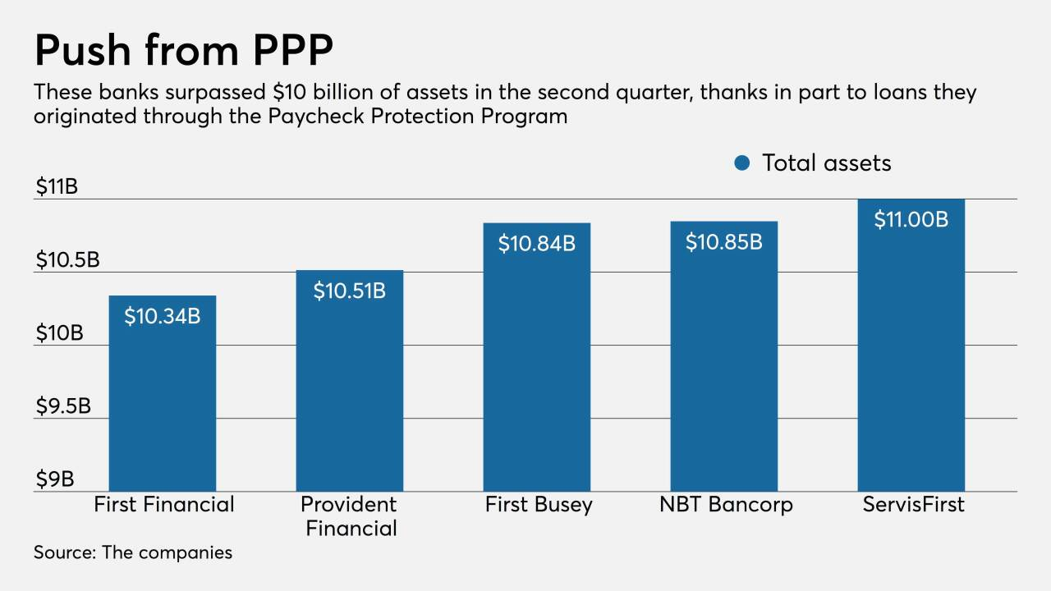

**Conclusions:**

The Volcker Rule is an important regulatory policy aimed at reducing dangerous trading activities and increasing financial stability. While it has achieved its objectives of lowering proprietary trading and restricting bank interests in hedge funds and private equity funds, it has also been criticised for its complexity and compliance costs. Ongoing efforts to improve and simplify the regulation seek to strike a balance between the requirement for financial stability and the practical realities of financial institutions.